Pictorial instructions for altering the following settings on RMS:
- total number of appraisal allocations
- max. number of appraisals for each month

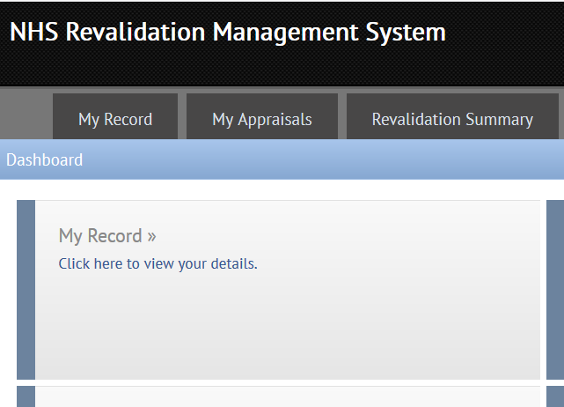

All of these settings are accessed from “My Record” on RMS dashboard
- Click on “ My Record” on RMS dashboard

Click on “My Record” - Then click on “Appraiser Summary” 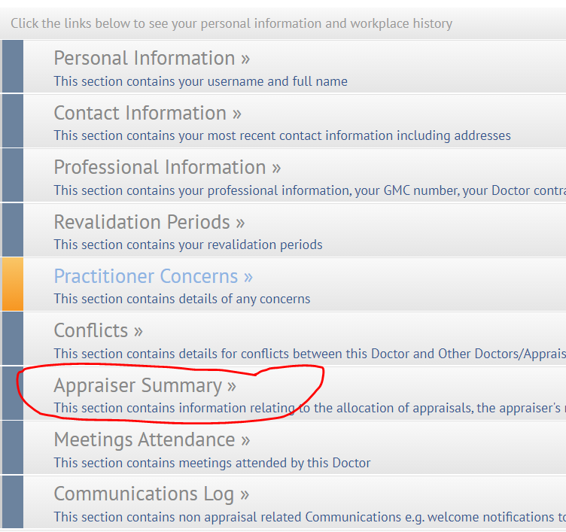

Select the correct year by clicking on the appropriate tab

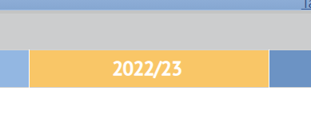

Then choose which area you wish to edit; total number of appraisals and number of appraisals per month shown below -
Remember to click SAVE each time you select a change or it will be lost.

GREEN - total number of appraisal allocations for the coming year. (20 is maximum)
Click to edit.
The office will not exceed this number but may well not be able to offer the maximum number of appraisals requested.
Remember to click “SAVE”

RED - Clicking here takes you to a page where you can set a maximum number of appraisals in any particular month and to mark yourself as unavailable in a certain month.
Remember to click “SAVE”

