Advice for working with PDF files.

Some files, most notably the MAG form, will only work properly when opened with Adobe Acrobat reader.
- So first of all download the latest version of Acrobat.
- If a dialogue box asks if you want Acrobat reader to be the default viewer, answer yes.

Some PDF files cannot be opened successfully by double clicking a link on a website or double clicking the file which is attached to an email.

- In this case you need to save the file to your computer first.

- Then navigate to the place where you saved it and open it in the usual way from there (i.e. double click the file which is saved on your computer, NOT the link on the website).

Windows users

- RIGHT CLICK (not the usual left click) the link on the website or the emailed attachment.

- From the menu which appears select “Save as” or Save target as”

- Then choose where you want to save it. If you don’t know where to save it, save to the desktop, where it will be easy to find again.

- Now navigate to where you saved the document on in your computer.

- Double click (double left click) the document to open with Acrobat Reader.

- If that last step fails, RIGHT CLICK the document and “Open with” Acrobat Reader.

Apple MAC users

Despite having installed Acrobat Reader on your Apple MAC the operating system may continue to try to use the default software called Preview which may not display certain PDF files correctly.

So these instructions may help:

- RIGHT CLICK (not the usual left click) the link on the website or email attachment.
(or '2 finger clicking' if you use a mouse pad).

- Save the document where you choose. If you don’t know where to save it, save to the desktop, where it will be easy to find again.

- Now navigate to where you saved the document on in your computer.

- RIGHT CLICK (not the usual left click) on the document and select “Open with”.

- Select the option for Acrobat Reader.
Completing a PDF form.

Some PDF documents contain forms to be completed with your information.

If you cannot just type in the box follow these instructions:

- Open the document with Acrobat Reader.

- In the right hand column you will find “Fill & Save” – click on that.

- Now click on the page where you want to enter data and begin typing.

- The box in which you typed can be moved by “dragging and dropping” it where you want to line it up correctly.

- For date grid boxes, insert spaces to get the numbers into the boxes.

- When you have finished, save the document where you can find it again. You might want to rename it at this stage so you will have a completed form as well as the original blank form.
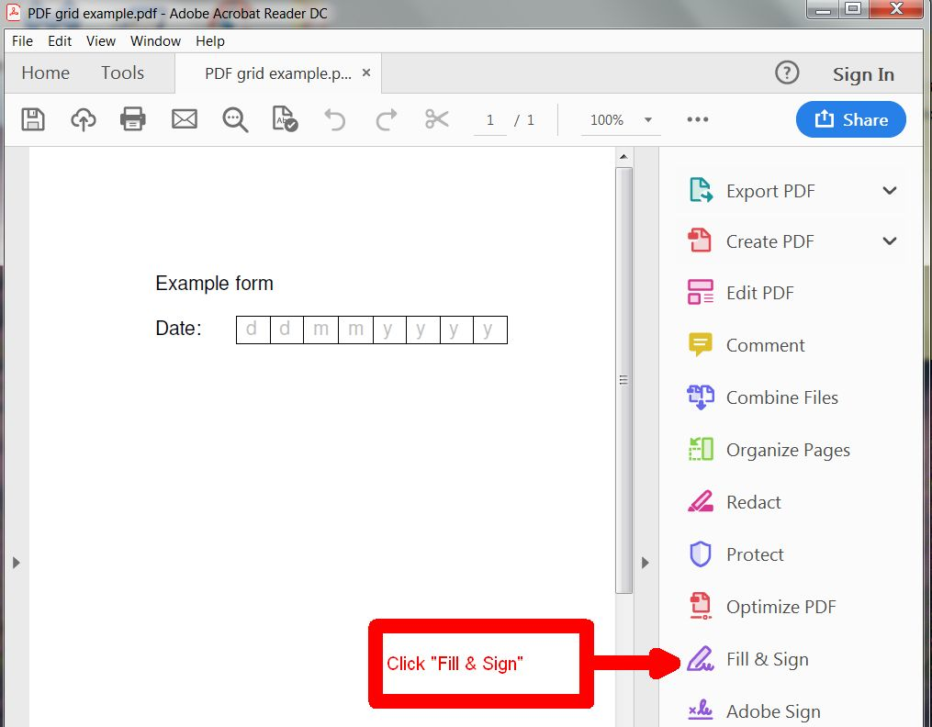

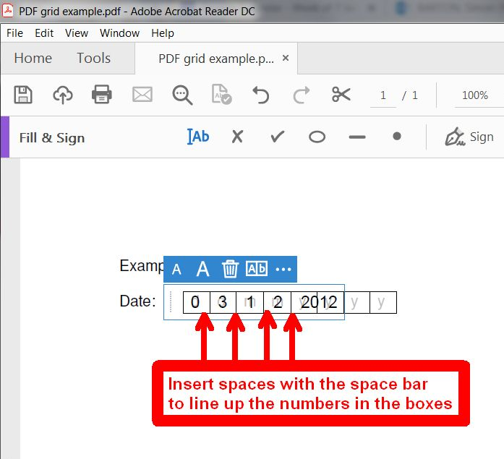

Simon Barton.
6th January 2019.

