- Booking onto a Meeting

From the list of meetings displayed on the Manage Meetings page, select a meeting and click on the Book button as shown below:

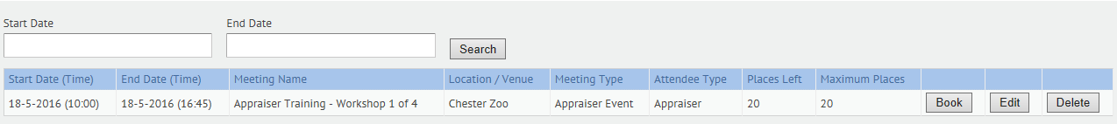

This will then display the following screen:

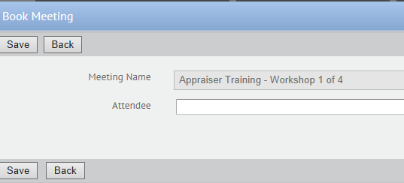

Attendees are selected by typing the first few characters of the name. The list displayed may include several people to select.

Select the person’s name from the list of possible options as shown below:

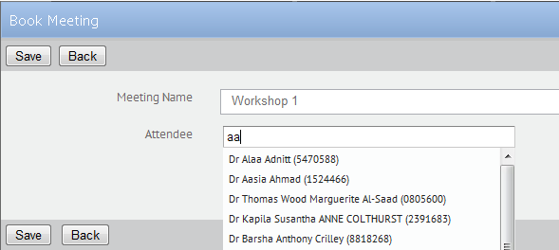

Click on the Save button to display the following confirmation message:

